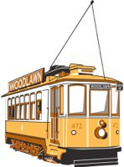
Woodlawn Neighborhood Association
gowoodlawn.com

Come join us for our annual meeting on Tuesday, October 1st at 7:00 pm at Classic Foods, 817 NE Madrona St.

We will have a potluck, socialization, and board elections for the upcoming year.

Bring something to share, or come anyway, if not!

